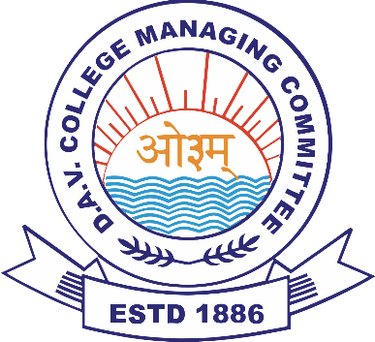
D.A.V. ASSTT. REGIONAL OFFICE
C.G. Zone H
(C/o DAV MukhyamantriPublic School Kewari, Lakhanpur, Dist-Surguja C.G.)
(Managed by DAV College Managing Committee, New Delhi)
Website – www. davmpskewari.in Phone Number-
DAV STAFF RECRUITMENT : Phase 3 (Demo & Interview)
(Teaching & Non-Teaching Staff for academic session 2025-26)
Tentative month of Demo/Interview in C.G. Zone H: March-2025
Kind Attention DAV CBT 2025 qualified candidates!
CBT 2025 qualified candidates will be contacted by DAV Regional Office, C.G. Zone-H to appear in Phase 3 (Demo & Interview) for the schools listed below, in the month of March-2025. Date and Venue of Demo-Interview will be shared via email/message/phone-call. Candidates must carry their CBT PEC 2025, all original certificates/documents to the allotted venue on the allotted date. For convenience, candidates will be called in batches or groups. For any queries, PEC holders may contact the zone/school on the provided contact number/s.
SCHOOLS IN C.G. ZONE- H
School Name & Complete Address (with pin code) | School website | School contact no.
- DAV Mukhyamantri Public School, Kewari, Lakhanpur, Dist- Surguja (CG)- 497116 | www.davmpskewari,in | 9755907090
- DAV Mukhyamantri Public School, Parsa, Dist-Surguja (CG)- 497001 | www.davmpssurguja.in | 9340694933
- DAV Mukhyamantri Public School, Sanibarra, Dist- Surguja (CG)- 496117 | www.davmpssanibarra.in | 7000893106
- DAV Mukhyamantri Public School, Narmadapur, Mainpat, Dist-Surguja (CG)- 497111 | www.davmpsnarmadapur.in | 6263755760
- DAV Mukhyamantri Public School, Karanki, Lundra, Dist-Surguja (CG)- 497101 | www.davmpskaranki.in | 9171043921
- DAV Mukhyamantri Public School, Bhatko, Batauli, Dist- Surguja (CG)- 497101 | www.davmpsbhatko.in | 6260032884
- DAV Mukhyamantri Public School, Pratapgarh, Block-Sitapur, Dist-Surguja (CG)- 497114 | www.davmpspratapgarh.in | 9575566035
ARO,C.G. Zone H

