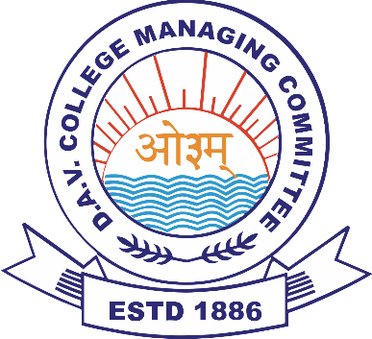
D.A.V. ASSTT. REGIONAL OFFICE
C.G. Zone C
(C/o DAV Mukhyamantri Public School, Tilsiwa, Dist-Surajpur C.G.)
(Managed by DAV College Managing Committee, New Delhi)
Website – www. davmpstilshiva.in Phone Number-7587017443
DAV STAFF RECRUITMENT : Phase 3 (Demo & Interview)
(Teaching & Non-Teaching Staff for academic session 2025-26)
Tentative month of Demo/Interview in C.G. Zone C: March-2025
Kind Attention DAV CBT 2025 qualified candidates!
CBT 2025 qualified candidates will be contacted by DAV Regional Office, C.G. Zone-C to appear in Phase 3 (Demo & Interview) for the schools listed below, in the month of March-2025. Date and Venue of Demo-Interview will be shared via email/message/phone-call. Candidates must carry their CBT PEC 2025, all original certificates/documents to the allotted venue on the allotted date. For convenience, candidates will be called in batches or groups. For any queries, PEC holders may contact the zone/school on the provided contact number/s.
SCHOOLS IN C.G. ZONE- C
School Name & Complete Address (with pin code) | School website | School contact no.
- DAV Mukhyamantri Public School, Tilsiwa Dist-Surajpur (CG)- 497223 | www.davmpstilshiva.in | 7587017443
- DAV Mukhyamantri Public School, Kanaknagar Dist-Surajpur (CG)- 497223 | www.davmpskanaknagar.in | 8858217717
- DAV Mukhyamantri Public School, Kalamanjan Dist-Surajpur (CG)- 497231 | www.davmpskalamanjan.in | 8319971187
- DAV Mukhyamantri Public School, Jamdi, Bhaiyathan Dist-Surajpur (CG)- 497231 | www.davmpsJamdi.in | 9575867666
- DAV Mukhyamantri Public School, Sakariya Dist-Korea (CG)- 497449 | www.davmpssakariya.in | 9893364489
- DAV Mukhyamantri Public School, Janakpur Dist-Korea (CG)- 497778 | www.davmpsjanakpur.in | 7587017423
- DAV Mukhyamantri Public School, Kachoud Dist-Korea (CG)- 497118 | www.davmpkachoud.in | 7000827195
ARO,C.G. Zone C

