Dear CBT candidate

CBT Registration & Fee Payment for CBT - January 2025 is starting from 25/11/24 to 10/12/24 on our official website <https://davrecruit.davcmc.in/>.

**HOW TO LOG IN?**

1. To login, please visit <https://davrecruit.davcmc.in/>

2. Enter User Id & Password.

* Your **User Id**will be - Your 10 digit registered mobile number (as entered in your application form)
* Your **Password** will be -  last 4 digits of your mobile number and 4 digits of year of birth (as entered in your application form)

For example,

If your phone number is 9876543210 and your year of birth is 1995,

* your User id will be - 9876543210
* your Password will be – 32101995

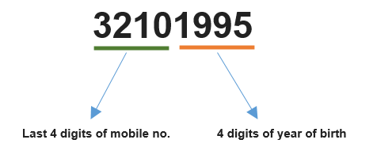

**HOW TO REGISTER ?**

For registration, you need to follow the following steps -

STEP 1 : Check if all your personal details are correct.

STEP 2 : Upload your recent passport size photograph. Face should be clear

STEP 3 : Upload your signatures. Signatures should be clear.

STEP 4 : Submit the Registration Form.

STEP 5 : Pay CBT Exam Fee Rs. 300/-

STEP 6 : Print

**IMPORTANT :**

**In case you find any error in the details or you are not able to log in, please contact the school at……………………………**