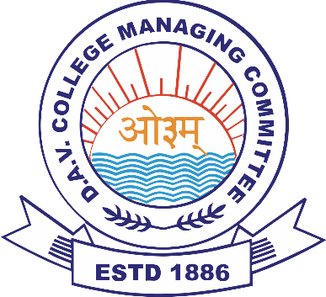
D.A.V. R OFFICE
H.R. Zone E
(C/o ID DAV Junior Public School, Sector-14, Hisar – 125 001)
(Managed by DAV College Managing Committee, New Delhi)
Website – smileiddavhsr.ac.in Phone Number – 94666 43601

DAV STAFF RECRUITMENT : Phase 3 (Demo & Interview)
(Teaching & Non-Teaching Staff for academic session 2025-26)
Tentative month of Demo/Interview in H.R. Zone E: March/April - 2025
Kind Attention DAV CBT 2025 qualified candidates!
CBT 2025 qualified candidates will be contacted by DAV Regional Office, H.R. Zone E to appear in Phase 3 (Demo & Interview) for the schools listed below, in the month of March/April - 2025. Date and Venue of Demo-Interview will be shared via email/message/phone-call. Candidates must carry their CBT PEC 2025, all original certificates/documents to the allotted venue on the allotted date. For convenience, candidates will be called in batches or groups. For any queries, PEC holders may contact the zone/school on the provided contact number/s.
SCHOOLS IN H.R. ZONE E
School Name & Complete Address (with pin code) | School website | School contact no.
- DAV CENTENARY PUBLIC SCHOO, KAUNT ROAD, BHIWANI-127021 | davbhiwani.org | 9254230570
- ID DAV PUBLIC SCHOOL, DABRA ROAD, HISAR – 125005 | smileiddavhsr.ac.in | 8901267459
- KL ARYA DAV PUBLIC SCHOOL, DN COLLEGE ROAD, HISAR – 125001 | klaryadavhsr.org | 01662-351023, 9034949868
- DAV CENTENARY PUBLIC SCHOOL, NEW HBC, BARNALA ROAD, SIRSA – 125055 | davsirsa.org | 7419247760
- MLS DAV PUBLIC SCHOOL, KULTAPUR ROAD, NARNAUL | mlsdavnarnaul.net.in | 01282-252474
- DAV CENTENARY PUBLIC SCHOOL, DELHI ROAD, NEAR ASTHAL BOHAR, ROHTAK | davrohtak.in | 7012060555
- DAV CENTENARY PUBLIC SCHOOL, KALANAUR | davschoolkalanaur.com | 9253636367, 8396927774
- DAV POLICE PUBLIC SCHOOL, NEW POLICE LINE. DELHI BY PASS HISAR | davppshisar.com | 9499338162, 8222877162
- DAV POLIC PUBLIC SCHOOL, SUNARIAN | Davpssunarian.in | 7082999252
- DAV POLICE PUBLIC SCHOOL, NEW POLICE LINE, HANSI ROAD, BHIWANI – 127021 | davppsbhiwani.com | 8813088906
- DAVRGTPP PUBLIC SCHOOL,THERMAL COLONY, KHEDAR – 125121 | davrgtppthermalkdrhsr.org | 9254240333
- DAV POLICE PUBLIC SCHOOL, POLICE LINE BARNALA ROAD, SIRSA – 125055 | policedavsirsa.com | 8198981081
- DAV POLICE PUBLIC SCHOOL, POLICE LINES, NARNAUL, MAHENERGARH – 123001 | davppsnnl.in | 9811459135
- DAV MAHATMA ANAND SWAMI CENTENARY PUBLIC SCHOOL, DATA ROAD, VIRAT NAGAR, HANSI | N.A | 7015904467, 7027059266
- DAV PUBLIC SCHOOL,KAMIRI ROAD, HISAR – 125001 | davkamiri.org | 01662-242926, 9255761903
- DAV PUBLIC SCHOOL, 792, JAGDISH COLONY , DLF, ROHTAK | davdlfknrohtak.in | 8307208277
- ID DAV JUNIOR PUBLIC SCHOOL, SECTOR-14, HISAR - 125001 | iddavjunior.in | 8901149537
RO/ARO, H.R. Zone E

