Tender Notice

DAV IPS Sector 8B, Bokaro DAV IPS Sector 9E, Bokaro DAV IPS Sector 2C, Bokaro DAV IPS Sector 12E, Bokaro

Tender No.: PRINTING/01 Date: 20/8/2025

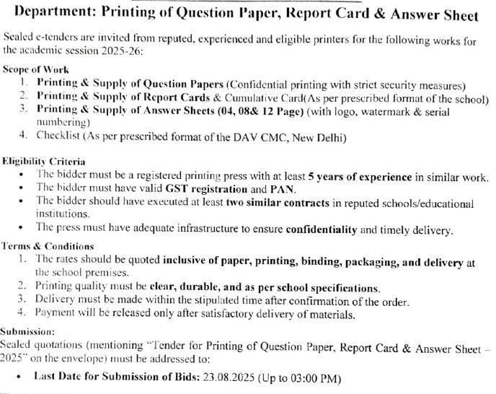

Submission Details:

* **Last Date for Submission of Tender:** 25/8/2025
* **Opening of Tender:** 20/8/2025 and at 10 a.m
* **Place of Submission:** DAV IPS Sector 8B, Bokaro
* **Contact Person:** Mr Dilip Kumar

The quotation should be also be sent via post/by hand/by mail id [davbsl8b@gmail.com](mailto:davbsl8b@gmail.com) .

**Note:** Incomplete tenders or tenders received after the due date will be rejected. Bidders are advised to visit the school during working hours for assessment, if needed.

M Mallik Teacher I/C